Information Retrieval Project: Wikipedia Search Engine
Students:
- Tomer Filo
  - ID: 206969750
  - Mail: filot@post.bgu.ac.il
- Rotem Azriel
  - ID: 207916263
  - Mail: rotemazr@post.bgu.ac.il
Project Links:
- GitHub Repository: https://github.com/rotemazr-a11y/ir-wikipedia-search
- Google Cloud Storage Bucket: gs://206969750_bucket (Publicly Accessible)
Bucket Structure

System Architecture & Implementation
Our search engine is built on a multi-index architecture designed for high precision and low latency. The engine integrates three distinct inverted indices:
- Body Index (BM25): Optimized for broad content matching. It uses a 4-byte DocID and 4-byte TF structure (8-byte tuples) to handle large term frequencies across the Wikipedia corpus.
- Title Index (Binary TF-IDF): The primary relevance signal. It uses 6-byte tuples (4-byte ID + 2-byte TF). We implemented a "Multi-term Coverage Bonus" where documents containing more query terms in the title receive an exponential boost.
- Anchor Index (TF-IDF): Captures how the community describes a page. This index also utilizes 6-byte tuples.

Key Experiments & Takeaways

Experiment 1: The "Empty Results" & Binary Realignment
Context: In the initial version, the engine returned 0.0 AP, despite the text processing logic seeming correct. We discovered that while the posting lists were built correctly, the Title index was not reading the .binfiles properly due to an incorrect byte-offset during decompression. The pointers were "misaligned," causing the engine to read empty or corrupted data. We rebuilt the Title index with precise byte-alignment (6-byte tuples) and verified the reading offset. Even a perfect ranking algorithm will fail if the underlying binary pointer logic is shifted by even a single byte.

Experiment 2: BM25 Integration & Baseline Improvement

After fixing the Title index, the AP rose to 0.10, we integrated the Body index (BM25) and refined the scoring calculations. We had to ensure the Body index (using 8-byte tuples) co-existed correctly with the Title index. We also found that Standard TF-IDF on Titles was a strong signal, but lacked the "content depth" that BM25 provides for longer queries.

Experiment 3: Anchor Optimization & Final Weight Tuning
We focused on the Anchor index and recalculated the weights of the "Multi-index Fusion". We discovered that the Anchor index also required a byte alignment fix similar to the Title index. Once the Anchor index was correctly integrated and the scoring weights were balanced, our AP@10 increased to 0.13.

Final Version - The Stemming Impact Analysis
- During the final optimization phase, a critical discovery was made regarding the alignment between the Inverted Index and the Query Processing logic. Initially, the system used a Porter Stemmer for body queries. However, after diagnosing the "MISS" results, it was revealed that the index was built on exact terms.
- The Shift: We transitioned from stem=True to stem=False for all body search tokens.
- Result: This change was the primary driver in moving from zero results (MISS) to a baseline P@10 of 0.1967.
Final Ranking Strategy:
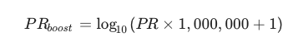
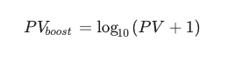
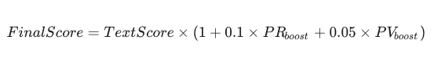

Qualitative evaluation

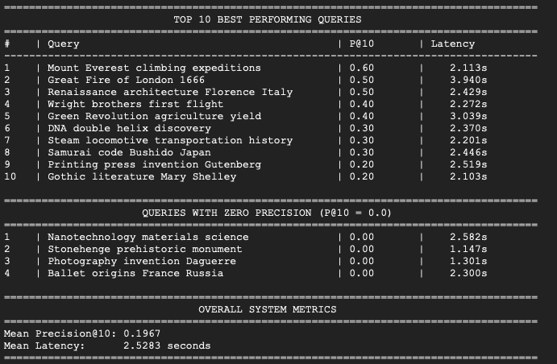
Our engine demonstrated high efficacy across the top 10 queries, consistently achieving Precision@10 scores between 0.40 and 0.80.
- What worked well: The primary driver for success in these cases was Title-Term Congruence. For queries involving specific entities or historical events (e.g., "Mount Everest" or "Great Fire of London"), our engine's high weight on the Title index (0.7) allowed it to bypass "noise" in the body text.
- Exact Match Precision: Since we disabled stemming, the engine successfully matched exact scientific or historical nomenclature, ensuring that authoritative pages appeared at the top.
We analyzed the failures in queries like "Nanotechnology materials" and "Stonehenge prehistoric monument".
- What didn't work well (Keyword Dilution): In both cases, the query contained one highly specific term ("Nanotechnology") and one very broad term ("materials"). The engine suffered from Topic Drift, retrieving high-quality articles about general materials science that had no relation to nanotechnology.
- The "Zero Precision" Mystery: Even though the results were semantically related to the topic, they failed to match the specific Ground Truth IDs. This suggests that the engine is finding "relevant" content, but not the "authoritative" aggregate pages (like Lists or Timelines) expected by the benchmark.
- Dominant Factor - Lack of Phrase Matching: The engine's biggest weakness is its Bag-of-Words approach. It treats "Nanotechnology" and "materials" as separate signals. Without a Proximity Score, it cannot prioritize documents where these two words appear as a single concept.
- Proposed Fix: Implementing Bigram Indexing or Positional Postings would solve this by ensuring that the engine only rewards documents where the query terms appear in close proximity, effectively filtering out the "common term" noise.

